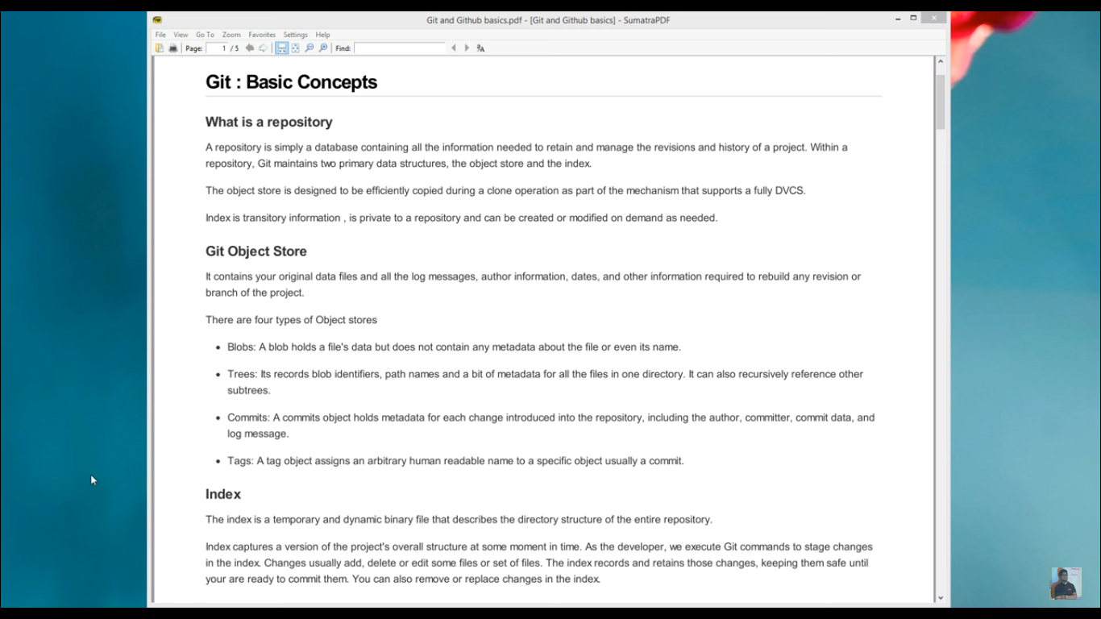

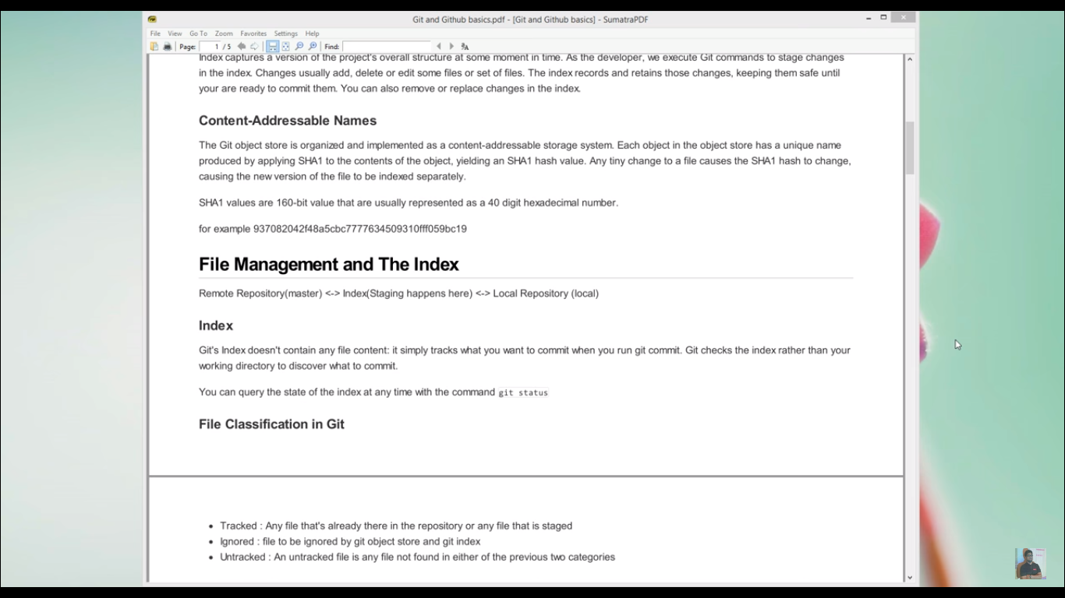

Msysgit for Command Line control of git

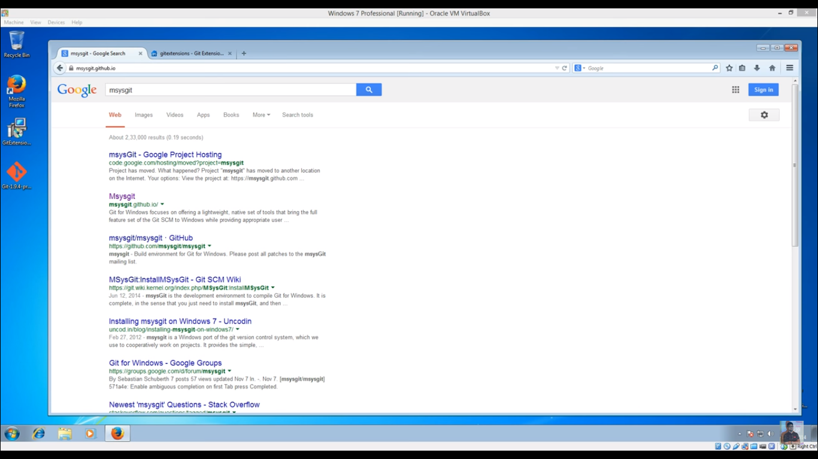

Git Extenstion for UI git software



Vedio Link : <https://www.youtube.com/watch?v=q-Z8zSM0blw>

Check git install on your computer successfully or not ?

* **Command** : git –version

Git Commands

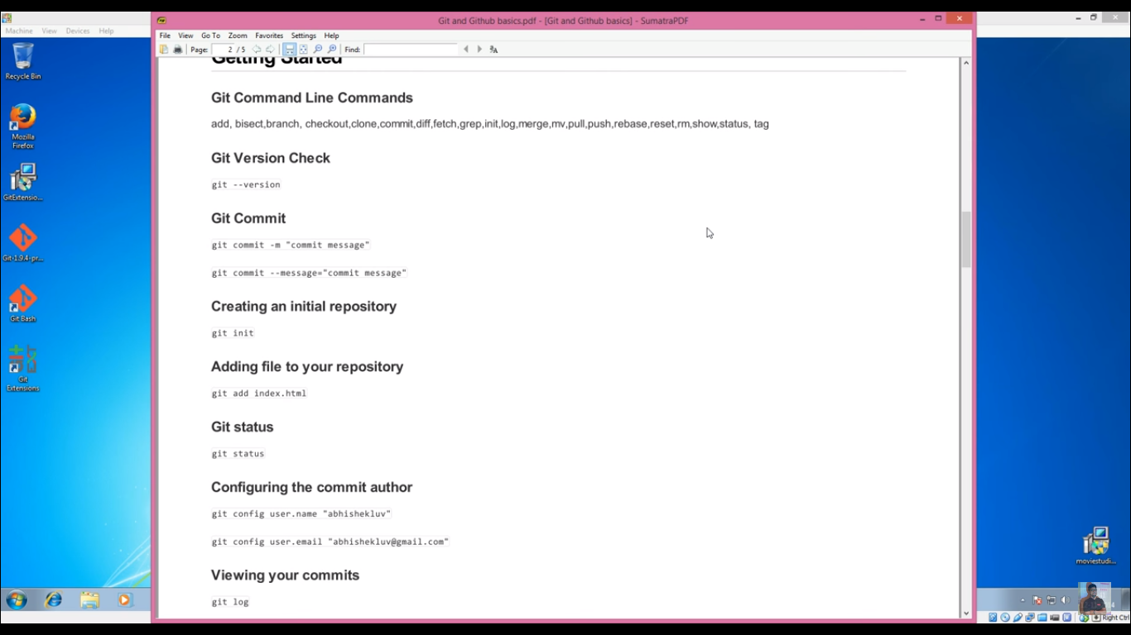

Then

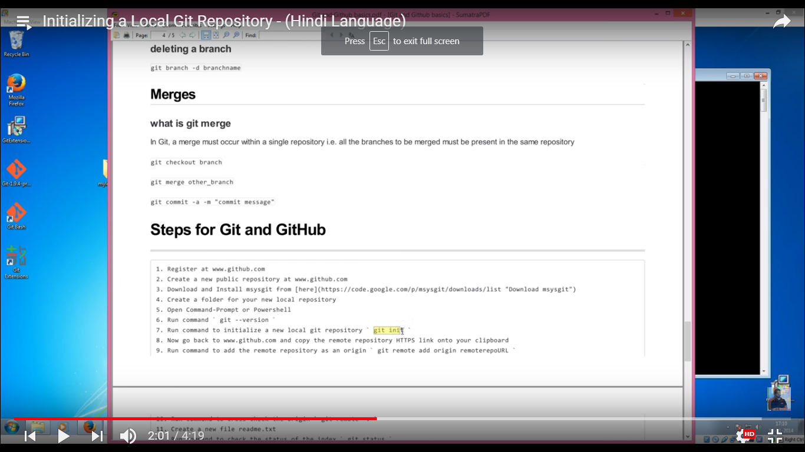

Login git again :

Go to URL : <https://github.com/>

Select your existing created repository or create new Repository.

Command to add local repository to git hub : **git remote add origin** https://github.com/psoni28/LearningGitHub.git

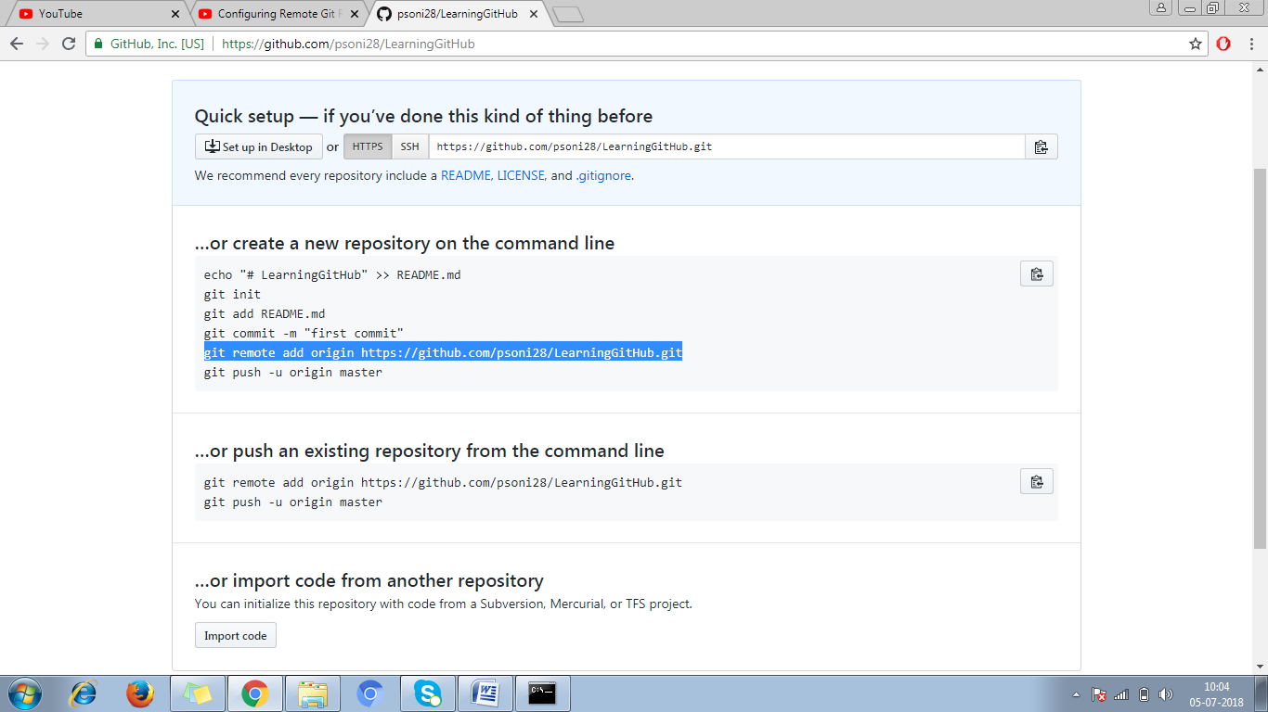

Check existing repository already added or not : **git remote –v**

To Remove existing repository command : -**git** **remote remove {name associate with repository at the time of adding }**

Example : **git remote remove origin**

Command to check current status of the git : **git status**

Command to add a file for staging or make ready for commit a file : **git add filename.extenstion**

Example : **git add prashant.txt**

Command to add all the files for staging : **git add –all**

Command to add all the files for staging : **git add .**

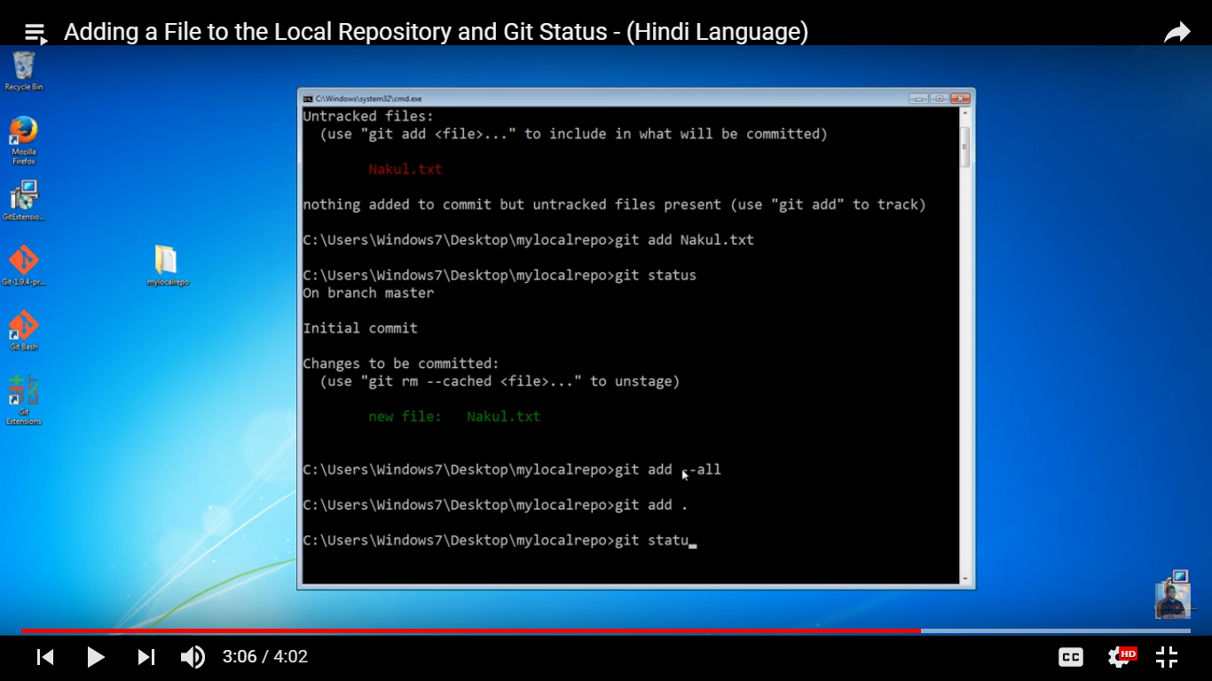

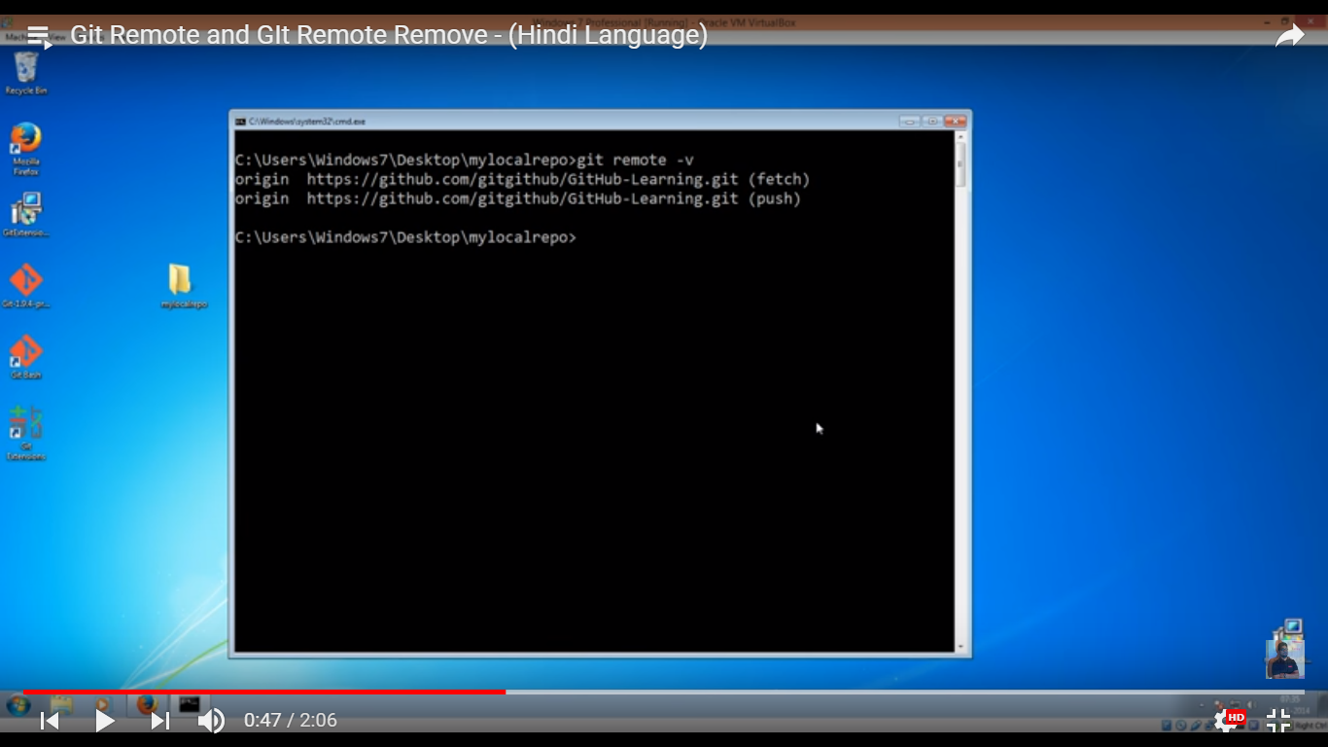

To Remove file from staging command : **git rm –cached filename.fileExtenstion**

Example : **git rm –cached prashant.txt**

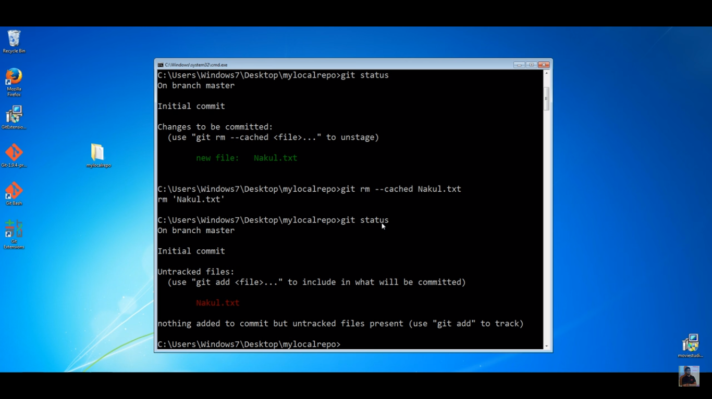

To ignore a file we need to create .gitignore file

Add the file name inside the .gitignore file which we want to ignore

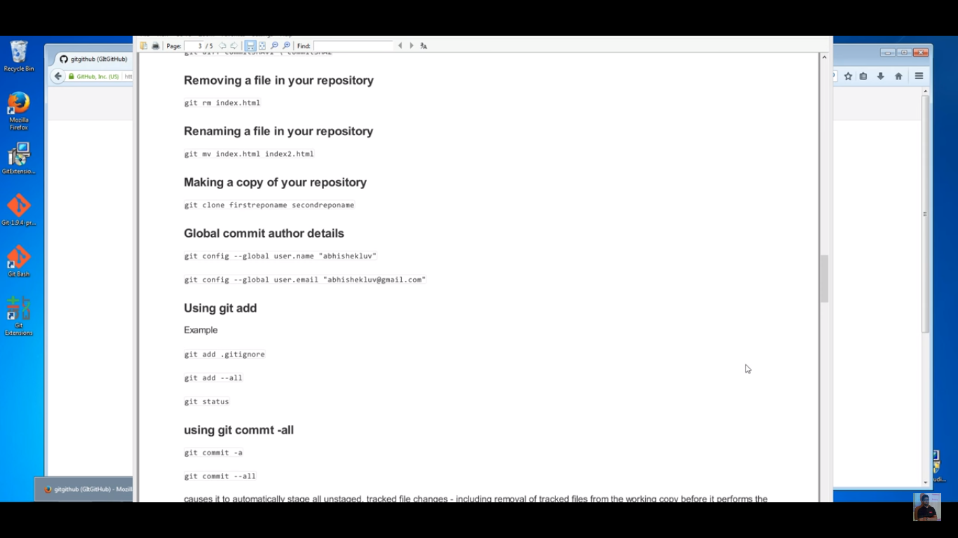

Configuration for user name and email address for commit command :

Command : git config –global user.name “psoni28”

Command : git config –global user.email [prashantsoni2810@gmail.com](mailto:prashantsoni2810@gmail.com)

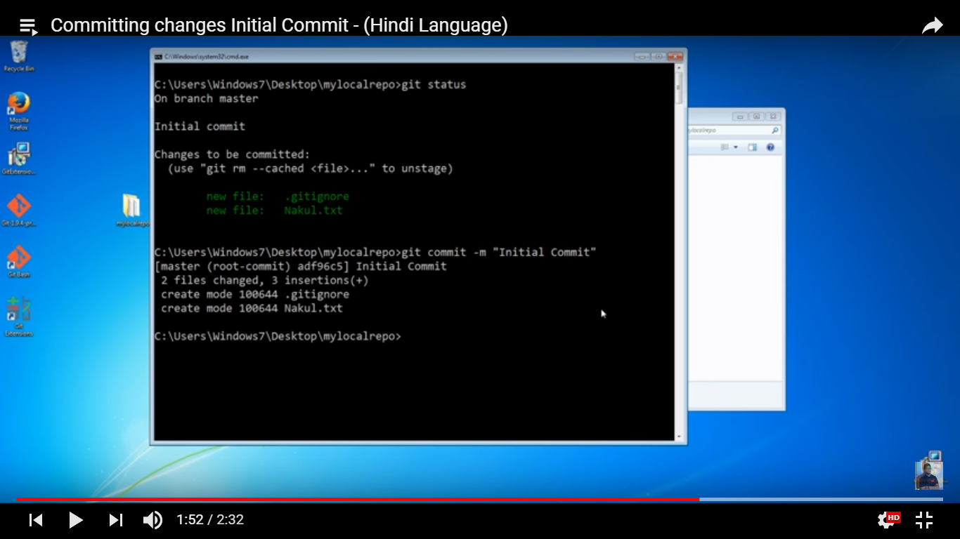

Command for initial commit : git commit –m “ Initial commit text message”

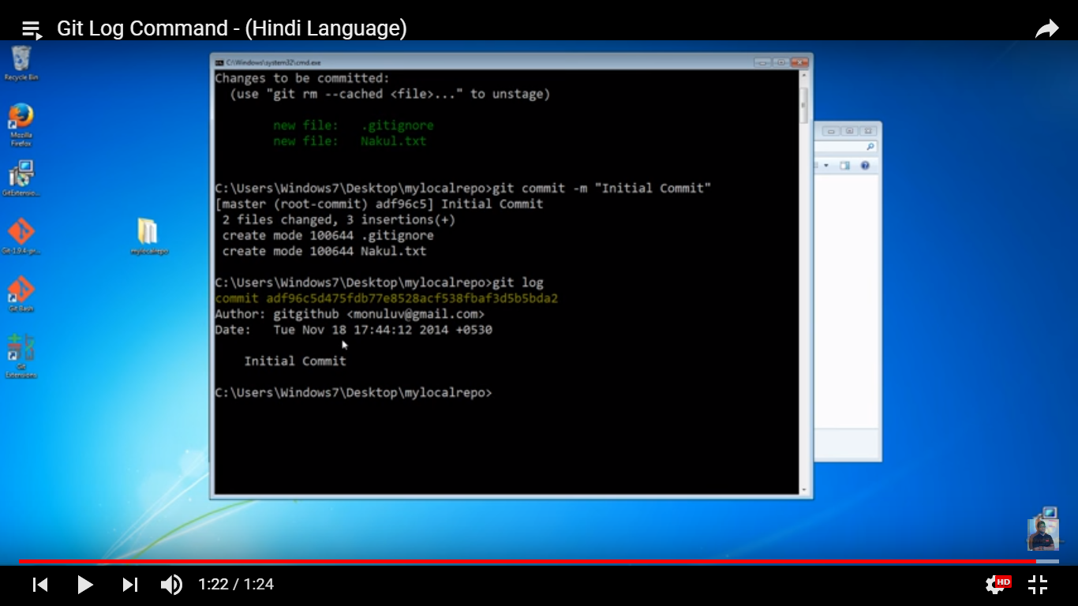

Command to check commit history log : **git log**

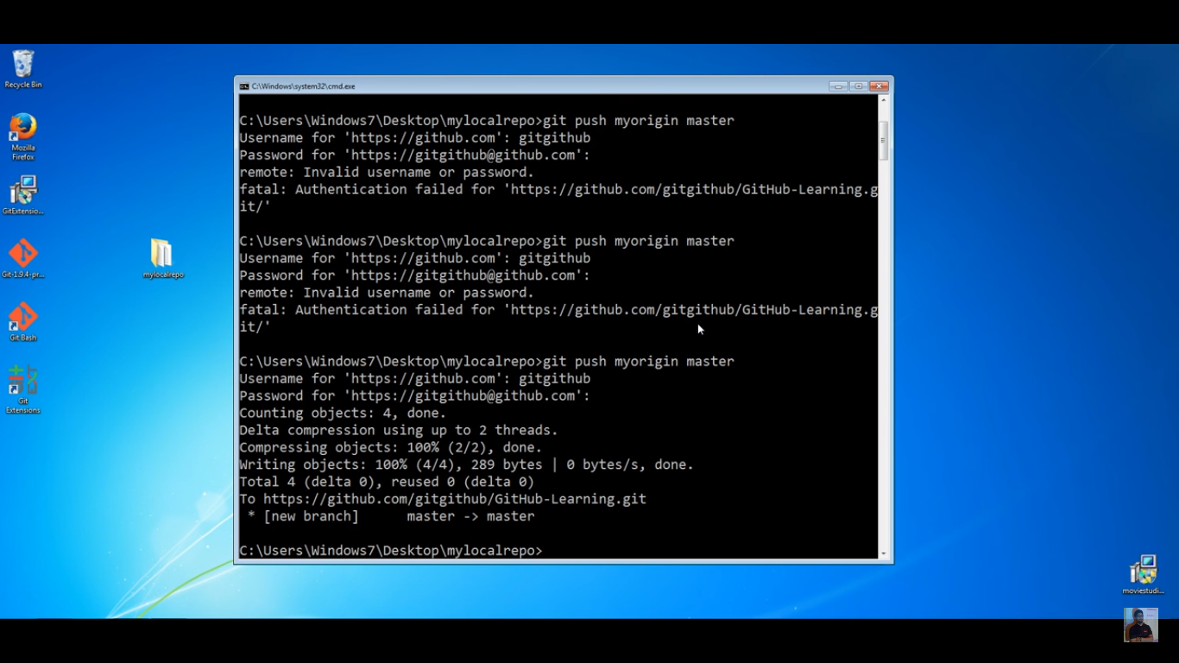

Command to push to remote respositry : **git push origin master**

**Then it will ask for user name and password , provide them , it will add all the file to remote respository.**

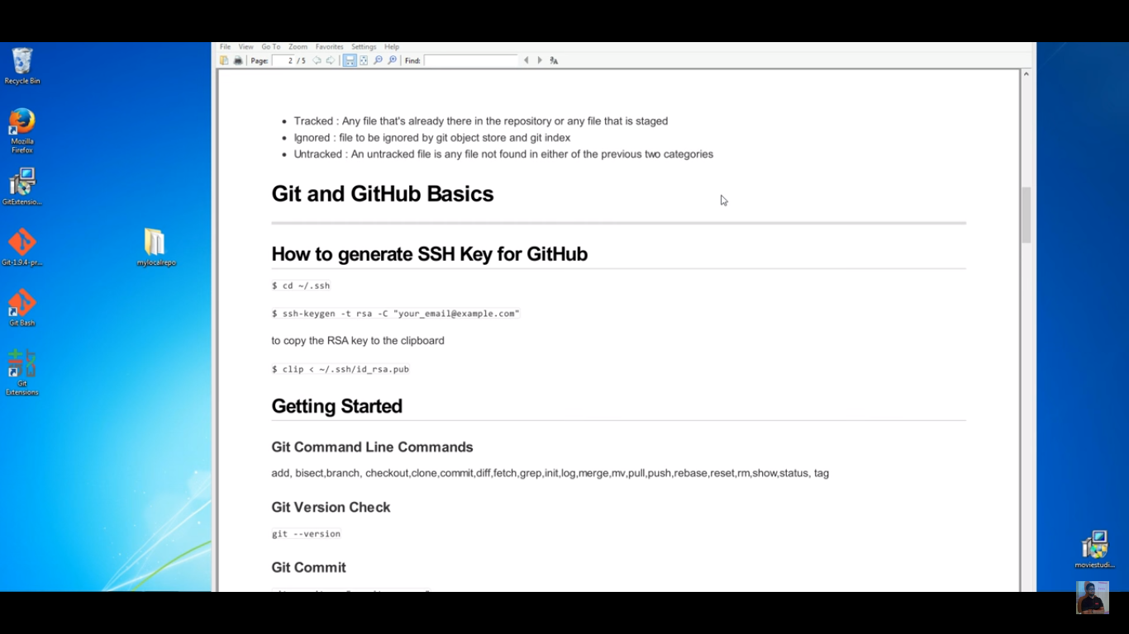

SSH key generate command : **ssh-keygen –t rsa –C “your_email@example.com”**

After that type enter three times and ssh key generated in folder **/c/Users/Samsung/.ssh/id_rsa.pub**

Go to .ssh folder : **cd .ssh**

Copy command to copy SSH Key **: clip < id_rsa.pub**

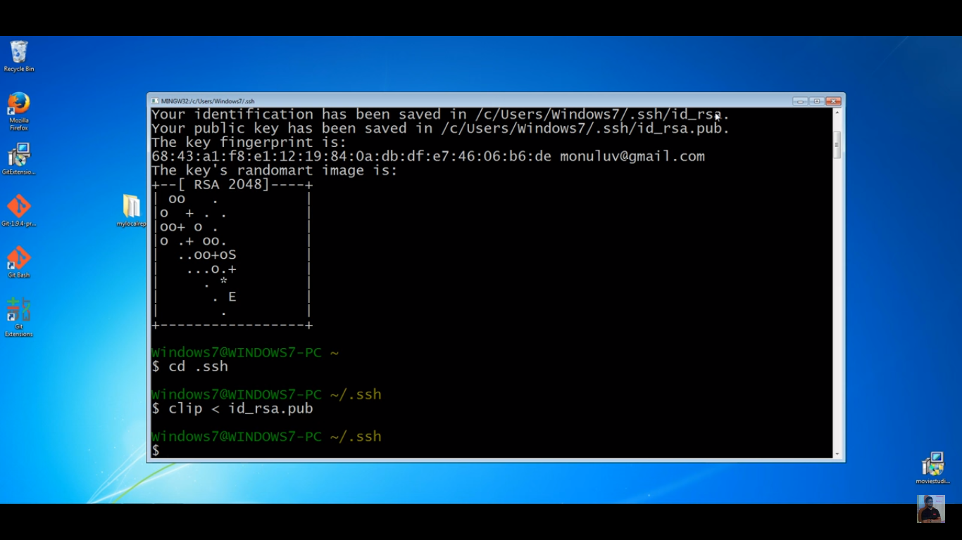

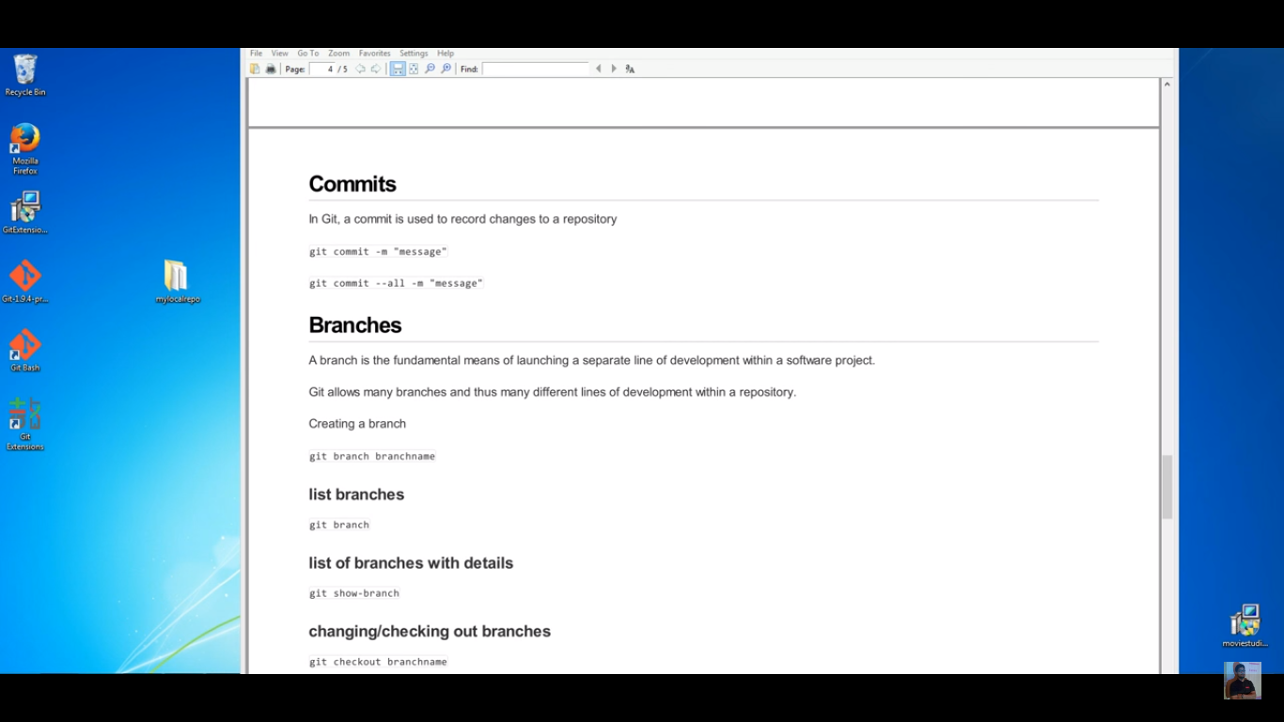

Command to show all the branches **: git branch**

Command to create new Branch **: git branch branch_name**

Command to go in specific branch **: git checkout branch_name**

Command to create new Branchand switch to that newly created branch **: git checkout –b branch_name**

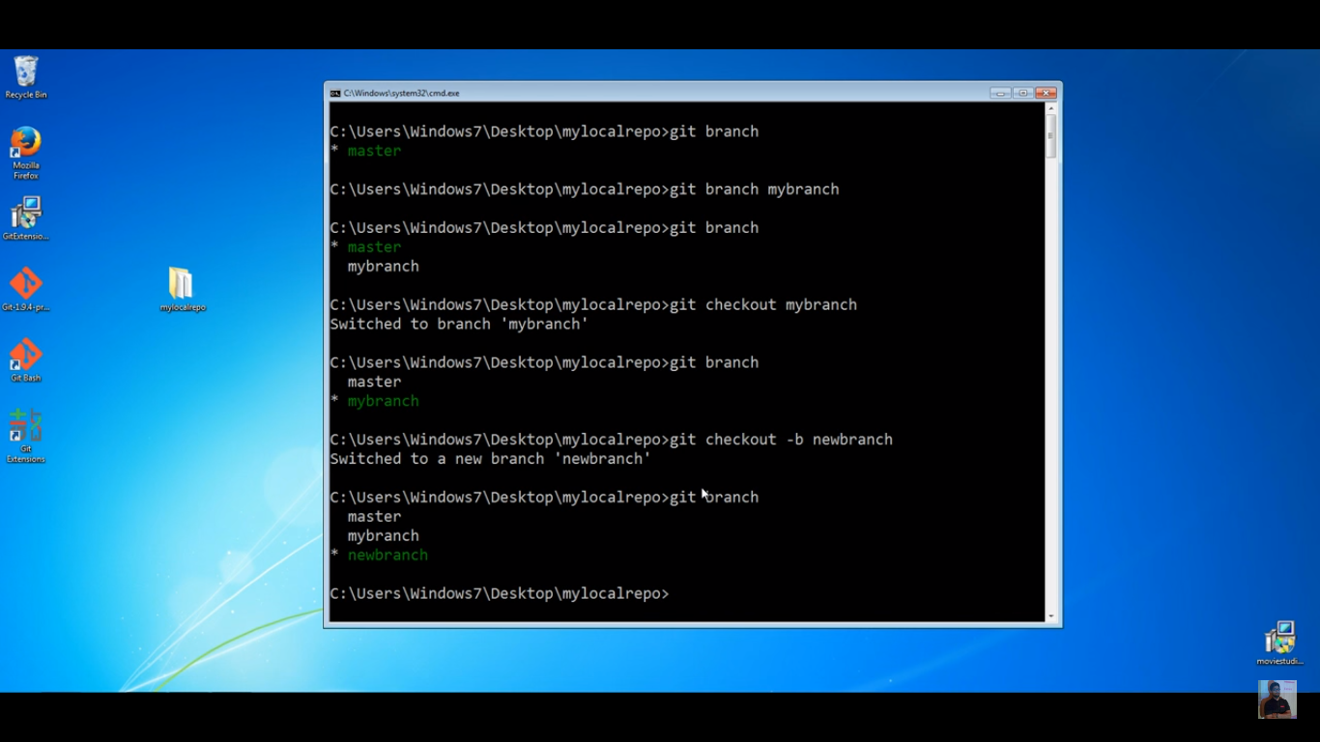

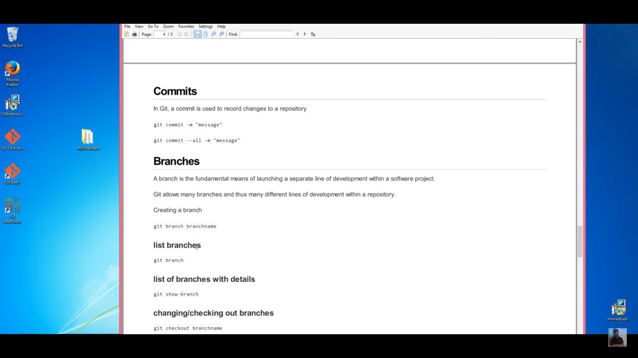

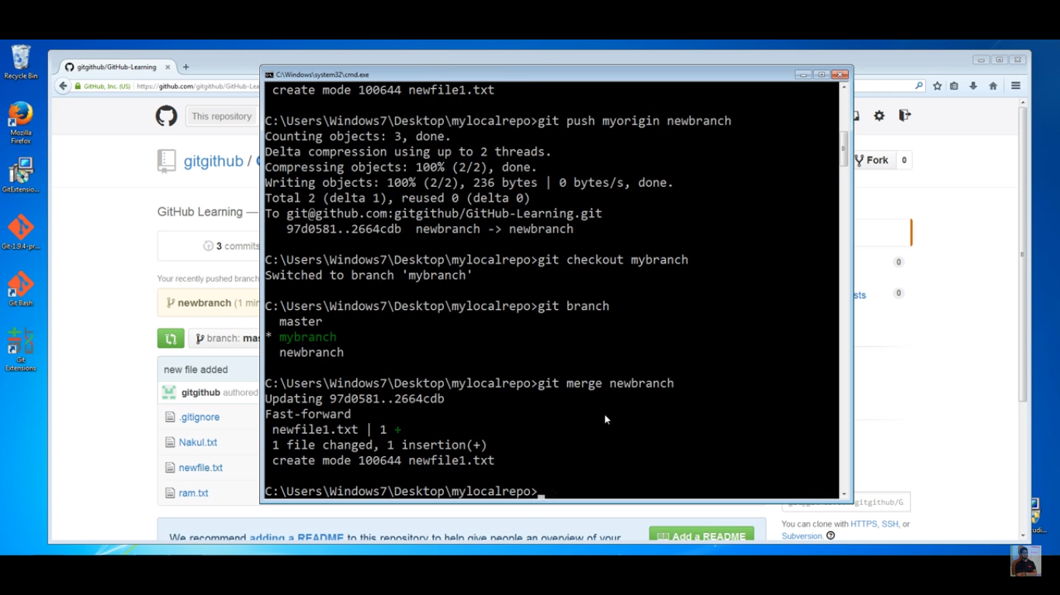

Command to merge two branches : **git merge { name_of_branch_from_code_need_to_merge_in_current_branch }**

Example **: git merge newbranch**

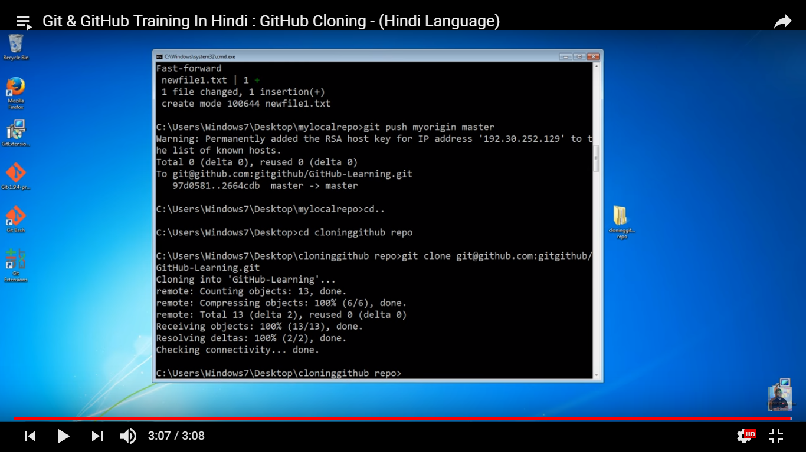

Steps to clone :

Copy SSH key from git hub UI as mention in below screen shot

Create local folder and switch to that folder from command using cd command

Command to clone in local machine or make copy of git hub repo files on local machine : **git clone ssh_key**

Example **: git clone git@github.com:psoni28/LearningGitHub.git**

